This data should be sent when tax bills are printed or August 15th at the latest (Which ever comes first). The State wants to receive the most recent updated data that you have. Sometimes they may request that you send a file in October, November, then the final copy in between January 1st – 15th. DO THIS PROCESS FROM THE GRAND LIST THAT YOUR TAX BILLS ARE PROCESSED AND MAINTAINED. In short if tax bills/revised bills are done on the Treasurers computer and you are NOT networked then you need to send these files from the Treasurers computer.

Now when you file the form 411 electronically the State Grand List Export file is included.
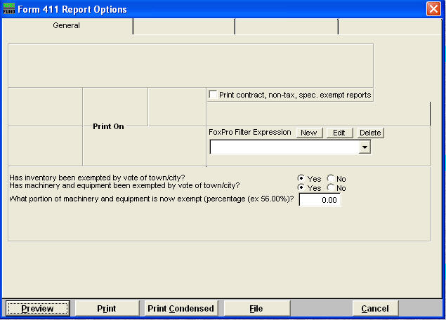
- Select (‘4’ Form 411) on the report menu.
- Choose the appropriate options for running this report.

3. Select ‘Send via Internet
OR
3B. File via diskette. Select the second option from the window seen to the right.
3C Insert a blank diskette and click the ‘Ok’ button.
3D Once this window appears data has been copied to the diskette and you may email, mail, or Ftp this file to the state.
NOTE: Both options will bring up the box below stating the process is complete.

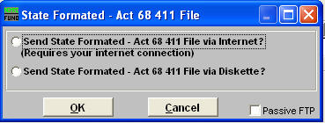

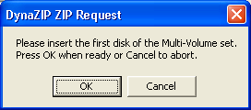

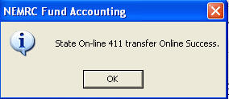

The files created and sent to PVR are also stored in your NEMRC Directory. They are as follows:

- 411EXP##.CSV – List of Totals of Exemptions in your Grand List. IE: Veterans, Contract, Farm Stabilization, Current Use, and Special Exemptions.

- 411LST##.CSV – List of all your parcels where Tax Status is Non Taxable and State Owned Land

- 411TFP##.CSV – Shows all parcels within your TIF District regardless of Parcel Status or Tax Status.

- 411TFS##.CSV – TIF Summary File, This shows the information displayed on the ‘Installation’ ‘TIF Setup’ tab

- 411TOT##.CSV –TIF district showing the information displayed on the ‘Installation’ ‘TIF Setup’ tab

- 411_GL##.CSV – All parcels on your Grand List report.

